CHAPTER 5: RESULTS AND DISCUSSION

5.1 Introduction
This chapter presents the results of the L-moments flood frequency analysis conducted on twenty rainfall stations in Terengganu, Malaysia. The methodology described in Chapter 3 was applied to address the four research objectives. Results are presented for both Annual Maximum Series (AMS) and daily rainfall data.

Chapter 5 — Reader’s Guide
The flowchart below outlines the logical flow of this chapter. Each section builds upon the previous one, progressing from parameter estimation through to the final overestimation quantification.
flowchart TD
A([🌧️ START: 20 Rainfall Stations\nTerengganu, Malaysia]) --> B
B[📐 §5.2 — Objective 1\nParameter Estimation Using L-Moments]
B --> B1[Calculate L-Moments\nL₁ Mean · L₂ Scale · τ₃ Skewness · τ₄ Kurtosis]
B1 --> B2[(Annual Maximum Series\nTables 5.1 & 5.3)]
B1 --> B3[(Daily Rainfall Series\nTables 5.2 & 5.4)]
B2 --> B4[L-Moment Ratio Diagram\nFigure 5.1 — Visual Distribution Identification]
B3 --> B4
B4 --> C
C[📊 §5.3 — Objective 2\nDistribution Selection & Goodness-of-Fit]
C --> C1[Fit 9 Candidate Distributions\nGUM · NOR · EXP · GEV · GLO · GNO · GPA · PE3 · KAP]
C1 --> C2[Goodness-of-Fit Tests\nMADI & MSDI Indices]
C2 --> C3{Best-Fitting\nDistribution?}
C3 -->|AMS — Mixed results| C4[Multiple distributions\nK4D dominant at 40%\nTable 5.23]
C3 -->|Daily — Unanimous| C5[4-Parameter Kappa K4D\n100% of stations\nTable 5.24]
C4 --> C6[Distribution Summary\nFigure 5.3 — Pie Charts]
C5 --> C6
C6 --> D
D[📈 §5.4 — Objective 3\nReturn Period Analysis]
D --> D1[Estimate Quantiles at Return Periods\n2 · 10 · 50 · 100 years]
D1 --> D2[AMS Return Values\nTable 5.25\n100-yr: 366–1125 mm]
D1 --> D3[Daily Return Values\nTable 5.26\n100-yr: 130–169 mm]
D2 --> D4[Return Period Curves Comparison\nFigure 5.5 — 3 Representative Stations]
D3 --> D4
D4 --> D5[Spatial Overview\nFigure 5.6 — Return Values Heatmap]
D5 --> E
E[⚠️ §5.5 — Objective 4\nOverestimation Quantification]
E --> E1[Compare AMS vs Daily Return Periods\nat 99th Percentile Magnitude]
E1 --> E2["Overestimation Factor\nOE = RP_AM ÷ (RP_Daily ÷ 365.25)"]
E2 --> E3["Results: Table 5.27\nOE Factor: 7.14x to 9.99x\nMean OE: 8.50x · Mean OE%: 750%"]
E3 --> E4[Station-level Charts
Figures 5.7 & 5.8]
E4 --> E5["🔬 §5.5.3 — Sensitivity Analysis
OE Factor across 6 Percentile Thresholds
90th · 95th · 97th · 99th · 99.5th · 99.9th"]
E5 --> E5a["Coverage: only 99th gives all 20 stations"]
E5 --> E5b["Stability: lowest CV at 99th — CV = 0.11"]
E5 --> E5c["Relevance: ~110 mm is engineering-extreme"]
E5a & E5b & E5c --> E5d["Conclusion: 99th percentile confirmed
Figures 5.9 & 5.10 — Table 5.28"]
E5d --> F
F[💬 §5.6 — Discussion\nInterpretation Across All Objectives]
F --> F1[Parameter Estimation §5.6.1]
F --> F2[Distribution Selection §5.6.2]
F --> F3[Return Period Analysis §5.6.3]
F --> F4[Overestimation Implications §5.6.4]
F1 & F2 & F3 & F4 --> G
G([✅ §5.7 — Summary\nKey Findings & Recommendations])
style A fill:#1a6ca8,color:#fff,stroke:#0d4f7c
style G fill:#1a6ca8,color:#fff,stroke:#0d4f7c
style B fill:#2e86ab,color:#fff,stroke:#1a5f7a
style C fill:#2e86ab,color:#fff,stroke:#1a5f7a
style D fill:#2e86ab,color:#fff,stroke:#1a5f7a
style E fill:#c0392b,color:#fff,stroke:#922b21
style E5 fill:#d35400,color:#fff,stroke:#a04000
style E5d fill:#e67e22,color:#fff,stroke:#ca6f1e
style F fill:#27ae60,color:#fff,stroke:#1e8449
style C3 fill:#f39c12,color:#fff,stroke:#d68910

5.2 Objective 1: Parameter Estimation Using L-Moments

5.2.1 L-Moments for Annual Maximum Series
Table 5.1 presents the L-moment statistics for all twenty stations.
Table 5.1: L-Moment Statistics for Annual Maximum Series
Station ID | Station Name | N | L₁ (Mean) | L₂ (Scale) | τ₃ (L-Skewness) | τ₄ (L-Kurtosis)
0551621RF | Stor JPS Kuala Terengganu | 34 | 215.06 | 42.34 | 0.0663 | 0.1781
0580041RF | Klinik Bidan Kg. Baru Ajil | 37 | 214.79 | 62.37 | 0.4666 | 0.3835
0600011RF | JPS Bukit Besi | 51 | 204.43 | 45.75 | 0.1913 | 0.1467
0600131RF | JPS Dungun | 30 | 224.34 | 46.02 | 0.0615 | 0.1777
0600141RF | Rumah Pam Paya Ketam | 34 | 197.83 | 43.98 | 0.1072 | 0.0954
0600151RF | JPS Kuala Dungun | 36 | 194.89 | 48.28 | 0.3254 | 0.2606
0620081RF | Rumah Pam Nyatoh | 41 | 241.32 | 56.44 | 0.1358 | 0.1717
0630011RF | JPS Kemaman | 51 | 205.46 | 56.54 | 0.3630 | 0.3075
0630121RF | JPS Kg. Ibok, Kemaman | 33 | 217.38 | 53.61 | 0.1947 | 0.0191
0670051RF | Rumah Pam Tok Sabah, Marang | 45 | 202.48 | 46.97 | 0.1752 | 0.1586
0670181RF | Kg. Tepuh, Hulu Terengganu | 43 | 225.63 | 56.36 | 0.1290 | 0.1085
0670211RF | Rumah Pam Padang Landak | 41 | 213.23 | 39.24 | 0.0241 | 0.0859
0670221RF | JPS Kuala Berang | 48 | 250.02 | 64.93 | 0.2012 | 0.2253
0670251RF | Rumah Pam Jerangau | 45 | 230.93 | 59.19 | 0.0902 | 0.0773
0670281RF | Kg. Menerong, Hulu Terengganu | 35 | 244.58 | 73.69 | 0.1542 | 0.0320
0680071RF | Balai Polis Kg. Dura | 35 | 289.65 | 91.25 | 0.3827 | 0.3436
0680081RF | Rumah Pam Rantau Petronas | 43 | 222.20 | 45.53 | 0.0314 | 0.0363
0690051RF | Rumah Pam Pengkalan Ranggon | 36 | 252.72 | 69.07 | 0.3171 | 0.2231
0700011RF | Rumah Pam Besut | 39 | 251.68 | 77.43 | 0.3835 | 0.3652
0700131RF | JPS Jertih, Besut | 32 | 284.87 | 80.51 | 0.1102 | 0.0659
Key Findings: - L₁ (mean) ranges from 194.89 to 289.65 mm - L₂ (scale) ranges from 39.24 to 91.25 mm - L-skewness (τ₃) is predominantly positive, ranging from 0.024 to 0.467 - L-kurtosis (τ₄) ranges from 0.019 to 0.384

5.2.2 L-Moments for Daily Rainfall Series
Table 5.2: L-Moment Statistics for Daily Rainfall Series
Station ID | Station Name | N | L₁ (Mean) | L₂ (Scale) | τ₃ (L-Skewness) | τ₄ (L-Kurtosis)
0551621RF | Stor JPS Kuala Terengganu | 6,391 | 18.76 | 11.38 | 0.5052 | 0.2988
0580041RF | Klinik Bidan Kg. Baru Ajil | 5,062 | 20.29 | 12.86 | 0.5446 | 0.3352
0600011RF | JPS Bukit Besi | 9,311 | 19.25 | 12.23 | 0.5462 | 0.3325
0600131RF | JPS Dungun | 6,185 | 20.01 | 12.12 | 0.5045 | 0.3012
0600141RF | Rumah Pam Paya Ketam | 6,161 | 19.52 | 11.67 | 0.4957 | 0.2915
0600151RF | JPS Kuala Dungun | 7,087 | 19.61 | 11.52 | 0.4715 | 0.2637
0620081RF | Rumah Pam Nyatoh | 8,110 | 20.88 | 12.56 | 0.5005 | 0.3033
0630011RF | JPS Kemaman | 9,651 | 18.89 | 11.75 | 0.5269 | 0.3128
0630121RF | JPS Kg. Ibok, Kemaman | 6,169 | 20.57 | 12.34 | 0.4964 | 0.2936
0670051RF | Rumah Pam Tok Sabah, Marang | 6,631 | 19.23 | 12.14 | 0.5418 | 0.3277
0670181RF | Kg. Tepuh, Hulu Terengganu | 8,555 | 19.78 | 12.11 | 0.5121 | 0.3089
0670211RF | Rumah Pam Padang Landak | 8,260 | 20.21 | 12.22 | 0.4990 | 0.2965
0670221RF | JPS Kuala Berang | 9,345 | 20.35 | 12.37 | 0.5017 | 0.2994
0670251RF | Rumah Pam Jerangau | 8,458 | 21.28 | 12.93 | 0.5105 | 0.3093
0670281RF | Kg. Menerong, Hulu Terengganu | 6,206 | 20.99 | 13.00 | 0.5273 | 0.3310
0680071RF | Balai Polis Kg. Dura | 7,683 | 23.43 | 13.99 | 0.4892 | 0.2921
0680081RF | Rumah Pam Rantau Petronas | 7,620 | 21.43 | 12.87 | 0.4980 | 0.2933
0690051RF | Rumah Pam Pengkalan Ranggon | 5,965 | 22.13 | 13.68 | 0.5266 | 0.3242
0700011RF | Rumah Pam Besut | 5,740 | 20.68 | 12.87 | 0.5344 | 0.3303
0700131RF | JPS Jertih, Besut | 5,182 | 20.14 | 12.70 | 0.5470 | 0.3441
Key Findings: - L₁ ranges from 18.76 to 23.43 mm (much lower than annual maxima) - L-skewness (τ₃) is consistently high (0.472 to 0.547), indicating right-skewed distributions - Daily data shows more consistent L-moment patterns across stations

5.2.3 L-Moment Ratio Diagram
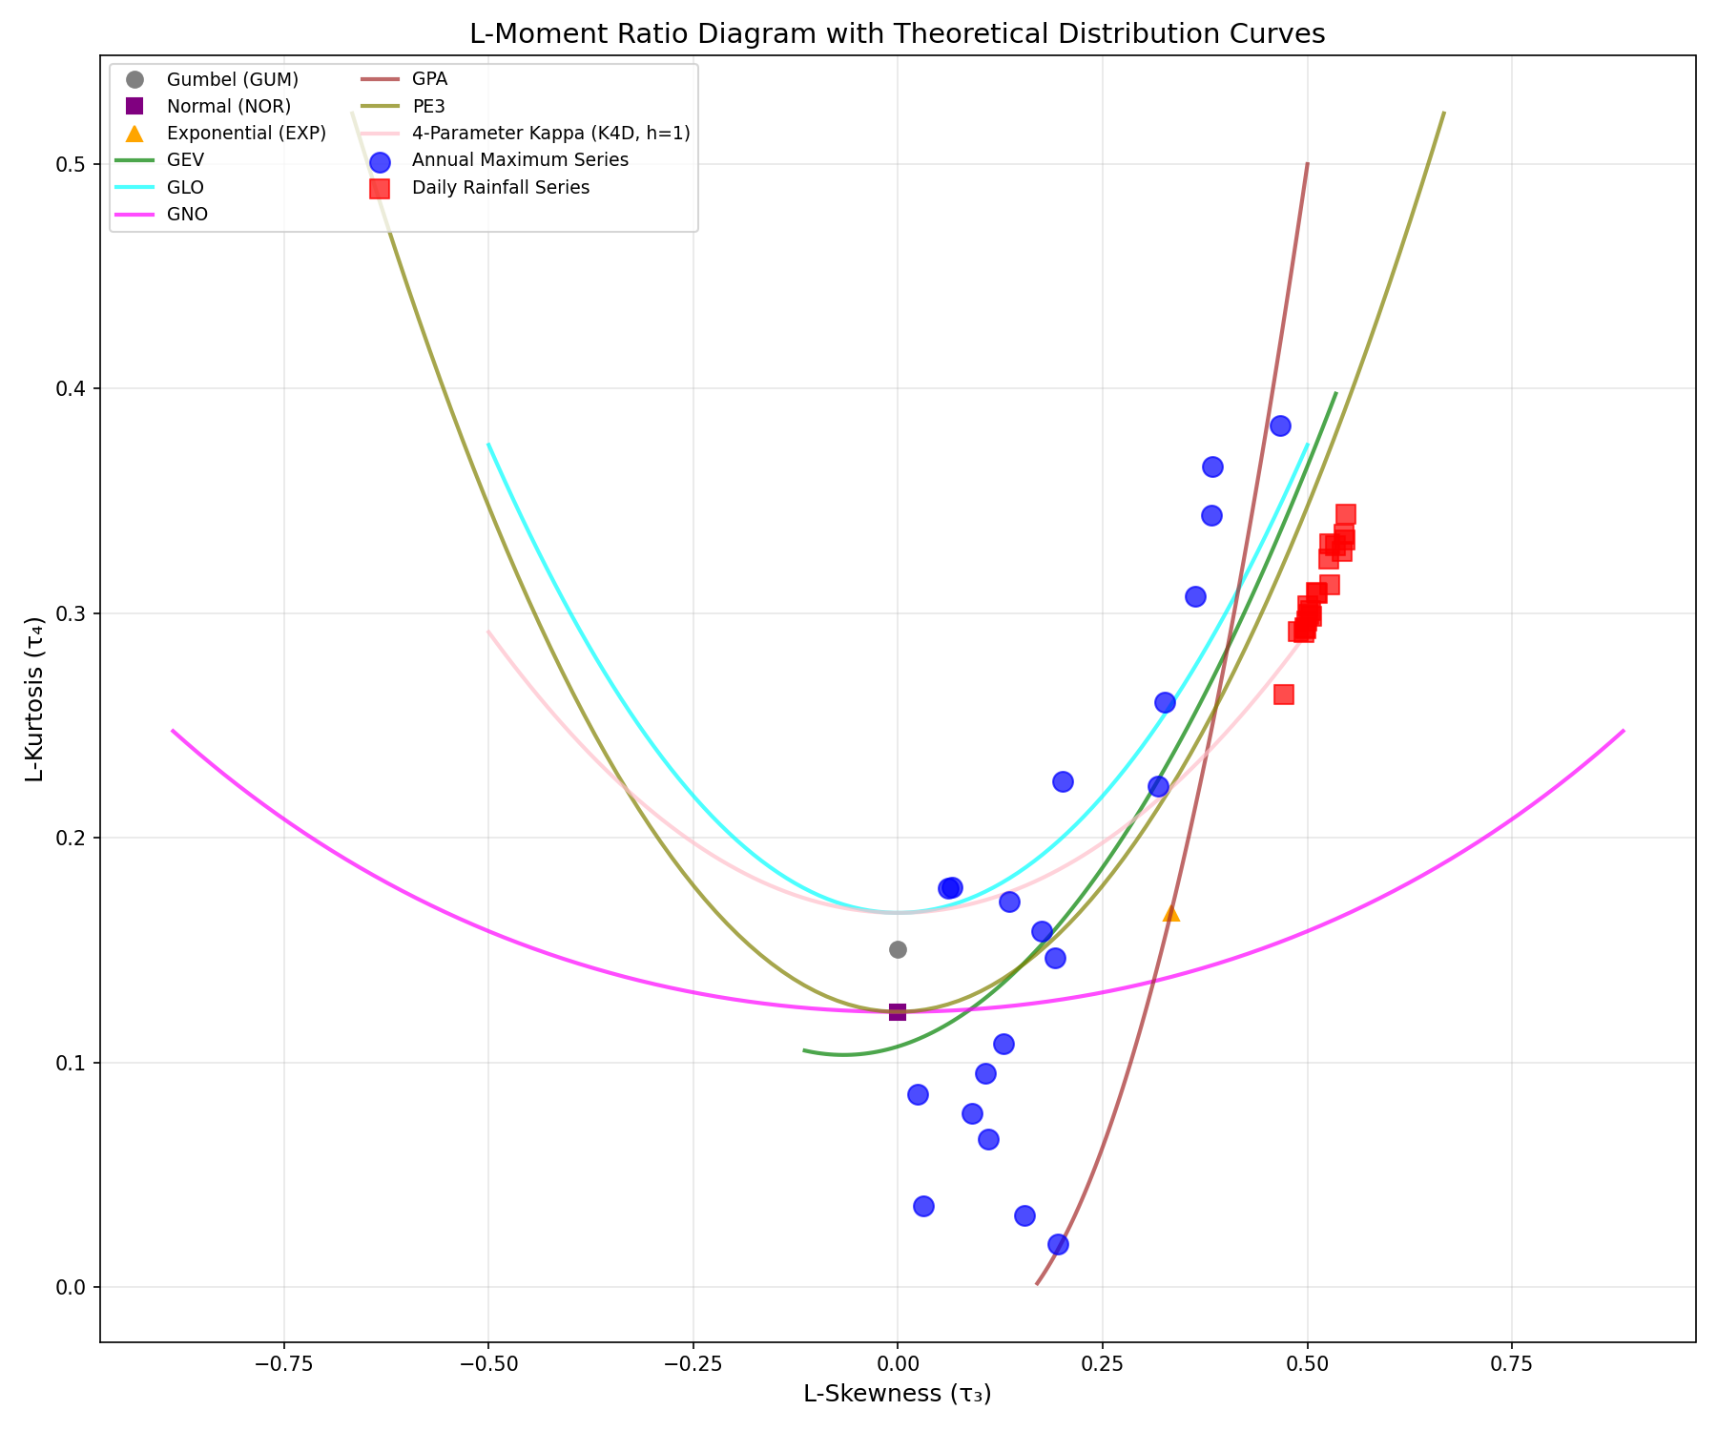
Figure 5.1: L-Moment Ratio Diagram
Figure 5.1: L-Moment Ratio Diagram comparing Annual Maximum Series (blue circles) and Daily Rainfall Series (red squares) with theoretical distribution curves. The theoretical curves represent the relationship between L-skewness (τ₃) and L-kurtosis (τ₄) for different probability distributions: Gumbel (GUM), Normal (NOR), Exponential (EXP), Generalized Extreme Value (GEV), Generalized Logistic (GLO), Generalized Normal (GNO), Generalized Pareto (GPA), Pearson Type III (PE3), and 4-Parameter Kappa (K4D). These curves help identify which theoretical distributions are most appropriate for the observed data by showing where the empirical data points fall relative to the theoretical relationships.
Key Observations: - Annual Maximum Series data points (blue circles) are scattered across a wider range of L-skewness (0.02 to 0.47) and L-kurtosis (0.02 to 0.38), indicating greater variability in distribution shapes across stations. - Daily Rainfall Series data points (red squares) cluster tightly in a high L-skewness region (0.47-0.55) with L-kurtosis values between 0.26 and 0.34, demonstrating consistent distributional characteristics across all stations. - Theoretical Distribution Curves: The empirical data points for Daily Rainfall Series fall closest to the 4-Parameter Kappa (K4D) distribution curve, which is consistent with the goodness-of-fit results showing K4D as the best-fitting distribution for all daily rainfall stations. The Annual Maximum Series points are more dispersed, with some stations near GLO, GNO, PE3, and K4D curves, reflecting the diversity of best-fitting distributions identified through MADI/MSDI analysis. - Distribution Selection Validation: The proximity of empirical points to theoretical curves provides visual confirmation of the distribution selection results, where K4D was selected for all daily stations, while Annual Maximum stations showed more variation (K4D, GLO, PE3, GNO, GPA, and GEV).

5.2.4 Distribution Parameter Estimation
Following the calculation of L-moments, distribution parameters were estimated for all nine candidate distributions using the method of L-moments. The estimated parameters are essential for subsequent goodness-of-fit testing and distribution selection.

5.2.4.1 Best-Fitting Distribution Parameters
The estimated parameters for the best-fitting distributions (identified through MADI/MSDI goodness-of-fit testing) are presented in Tables 5.5 and 5.6. These parameters were estimated using the method of L-moments as described in Chapter 3.
Table 5.3: Estimated Parameters for Best-Fitting Distributions (Annual Maximum Series)
Station ID | Station Name | Distribution | Parameter 1 | Parameter 2 | Parameter 3 | Parameter 4
0551621RF | Stor JPS Kuala Terengganu | PE3 | loc = 215.06 | scale = 75.44 | skew = 0.4063 | -
0580041RF | Klinik Bidan Kg. Baru Ajil | GEV | loc = 150.38 | scale = 50.89 | - | -
0600011RF | JPS Bukit Besi | K4D | loc = 158.98 | scale = 70.68 | k = 0.0118 | h = 0.1582
0600131RF | JPS Dungun | PE3 | loc = 224.34 | scale = 81.94 | skew = 0.3771 | -
0600141RF | Rumah Pam Paya Ketam | K4D | loc = 146.46 | scale = 91.81 | k = 0.2433 | h = 0.3573
0600151RF | JPS Kuala Dungun | GLO | loc = 170.36 | scale = 40.30 | k = -0.3254 | -
0620081RF | Rumah Pam Nyatoh | GNO | loc = 227.54 | scale = 96.85 | k = -0.2791 | -
0630011RF | JPS Kemaman | GLO | loc = 173.82 | scale = 45.06 | k = -0.3630 | -
0630121RF | JPS Kg. Ibok, Kemaman | K4D | loc = -65.33 | scale = 400.17 | k = 0.7719 | h = 1.6802
0670051RF | Rumah Pam Tok Sabah, Marang | PE3 | loc = 202.48 | scale = 86.24 | skew = 1.0630 | -
0670181RF | Kg. Tepuh, Hulu Terengganu | GPA | loc = 82.30 | scale = 221.17 | c = -0.5431 | -
0670211RF | Rumah Pam Padang Landak | K4D | loc = 176.56 | scale = 83.70 | k = 0.3575 | h = 0.2390
0670221RF | JPS Kuala Berang | GNO | loc = 226.77 | scale = 107.08 | k = -0.4157 | -
0670251RF | Rumah Pam Jerangau | K4D | loc = 150.83 | scale = 143.56 | k = 0.3418 | h = 0.4815
0670281RF | Kg. Menerong, Hulu Terengganu | K4D | loc = 1.01 | scale = 358.16 | k = 0.6172 | h = 1.2381
0680071RF | Balai Polis Kg. Dura | GLO | loc = 236.22 | scale = 70.80 | k = -0.3827 | -
0680081RF | Rumah Pam Rantau Petronas | K4D | loc = 136.97 | scale = 164.13 | k = 0.6443 | h = 0.7154
0690051RF | Rumah Pam Pengkalan Ranggon | K4D | loc = 184.77 | scale = 79.47 | k = -0.2098 | h = 0.0405
0700011RF | Rumah Pam Besut | GLO | loc = 206.26 | scale = 60.01 | k = -0.3835 | -
0700131RF | JPS Jertih, Besut | GPA | loc = 75.31 | scale = 335.91 | c = -0.6029 | -
Note: Parameter notation: loc = location parameter, scale = scale parameter, k = shape parameter (for GEV, GLO, GNO, K4D), h = second shape parameter (4-Parameter Kappa distribution only), skew = skewness parameter (Pearson Type III), c = shape parameter (Generalized Pareto). For GEV distribution at station 0580041RF, the shape parameter k approaches zero, indicating a Gumbel-like distribution.
Table 5.4: Estimated Parameters for 4-Parameter Kappa Distribution (Daily Rainfall Series)
Station ID | Station Name | Location (loc) | Scale (scale) | Shape 1 (k) | Shape 2 (h)
0551621RF | Stor JPS Kuala Terengganu | -5.66 | 15.93 | -0.2596 | 1.4743
0580041RF | Klinik Bidan Kg. Baru Ajil | -7.78 | 16.44 | -0.3132 | 1.6412
0600011RF | JPS Bukit Besi | -8.83 | 16.38 | -0.2993 | 1.7428
0600131RF | JPS Dungun | -5.10 | 16.42 | -0.2701 | 1.4105
0600141RF | Rumah Pam Paya Ketam | -5.07 | 16.46 | -0.2509 | 1.4142
0600151RF | JPS Kuala Dungun | -6.34 | 18.50 | -0.1899 | 1.4547
0620081RF | Rumah Pam Nyatoh | -3.57 | 16.17 | -0.2846 | 1.2879
0630011RF | JPS Kemaman | -8.27 | 16.72 | -0.2675 | 1.6823
0630121RF | JPS Kg. Ibok, Kemaman | -5.04 | 17.11 | -0.2571 | 1.3901
0670051RF | Rumah Pam Tok Sabah, Marang | -8.80 | 16.56 | -0.2908 | 1.7364
0670181RF | Kg. Tepuh, Hulu Terengganu | -5.18 | 15.99 | -0.2834 | 1.4232
0670211RF | Rumah Pam Padang Landak | -4.98 | 16.72 | -0.2632 | 1.3860
0670221RF | JPS Kuala Berang | -5.06 | 16.74 | -0.2688 | 1.3864
0670251RF | Rumah Pam Jerangau | -4.82 | 16.79 | -0.2878 | 1.3815
0670281RF | Kg. Menerong, Hulu Terengganu | -3.74 | 15.20 | -0.3319 | 1.3190
0680071RF | Balai Polis Kg. Dura | -4.09 | 18.75 | -0.2643 | 1.2757
0680081RF | Rumah Pam Rantau Petronas | -5.80 | 18.11 | -0.2532 | 1.4271
0690051RF | Rumah Pam Pengkalan Ranggon | -5.64 | 17.09 | -0.3101 | 1.4401
0700011RF | Rumah Pam Besut | -5.85 | 15.98 | -0.3165 | 1.4958
0700131RF | JPS Jertih, Besut | -5.64 | 14.99 | -0.3399 | 1.5092
Note: All daily rainfall series use the 4-Parameter Kappa (K4D) distribution. The 4-Parameter Kappa distribution is a four-parameter distribution with location (loc), scale, and two shape parameters (k and h).

5.2.4.2 Comprehensive Parameter Tables for All Distributions
The following tables present estimated parameters for all nine distributions fitted to both Annual Maximum Series and Daily Rainfall Series data. These comprehensive tables provide complete parameter information for all distributions, allowing for comparison and reference. Parameters were estimated using the method of L-moments as described in Chapter 3.
Table 5.5: Estimated Parameters for GUM Distribution (Annual Maximum Series)
Station ID | Station Name | Location (loc) | Scale (scale)
0551621RF | Stor JPS Kuala Terengganu | 179.80 | 61.09
0580041RF | Klinik Bidan Kg. Baru Ajil | 162.84 | 89.99
0600011RF | JPS Bukit Besi | 166.33 | 66.00
0600131RF | JPS Dungun | 186.01 | 66.40
0600141RF | Rumah Pam Paya Ketam | 161.21 | 63.45
0600151RF | JPS Kuala Dungun | 154.68 | 69.66
0620081RF | Rumah Pam Nyatoh | 194.32 | 81.43
0630011RF | JPS Kemaman | 158.37 | 81.57
0630121RF | JPS Kg. Ibok, Kemaman | 172.74 | 77.34
0670051RF | Rumah Pam Tok Sabah, Marang | 163.36 | 67.77
0670181RF | Kg. Tepuh, Hulu Terengganu | 178.69 | 81.31
0670211RF | Rumah Pam Padang Landak | 180.56 | 56.61
0670221RF | JPS Kuala Berang | 195.95 | 93.67
0670251RF | Rumah Pam Jerangau | 181.64 | 85.40
0670281RF | Kg. Menerong, Hulu Terengganu | 183.21 | 106.32
0680071RF | Balai Polis Kg. Dura | 213.66 | 131.64
0680081RF | Rumah Pam Rantau Petronas | 184.28 | 65.68
0690051RF | Rumah Pam Pengkalan Ranggon | 195.20 | 99.64
0700011RF | Rumah Pam Besut | 187.20 | 111.71
0700131RF | JPS Jertih, Besut | 217.82 | 116.15
Table 5.6: Estimated Parameters for NOR Distribution (Annual Maximum Series)
Station ID | Station Name | Location (loc) | Scale (scale)
0551621RF | Stor JPS Kuala Terengganu | 215.06 | 75.05
0580041RF | Klinik Bidan Kg. Baru Ajil | 214.79 | 110.56
0600011RF | JPS Bukit Besi | 204.43 | 81.08
0600131RF | JPS Dungun | 224.34 | 81.57
0600141RF | Rumah Pam Paya Ketam | 197.83 | 77.95
0600151RF | JPS Kuala Dungun | 194.89 | 85.58
0620081RF | Rumah Pam Nyatoh | 241.32 | 100.05
0630011RF | JPS Kemaman | 205.46 | 100.22
0630121RF | JPS Kg. Ibok, Kemaman | 217.38 | 95.02
0670051RF | Rumah Pam Tok Sabah, Marang | 202.48 | 83.26
0670181RF | Kg. Tepuh, Hulu Terengganu | 225.63 | 99.89
0670211RF | Rumah Pam Padang Landak | 213.23 | 69.55
0670221RF | JPS Kuala Berang | 250.02 | 115.08
0670251RF | Rumah Pam Jerangau | 230.93 | 104.91
0670281RF | Kg. Menerong, Hulu Terengganu | 244.58 | 130.62
0680071RF | Balai Polis Kg. Dura | 289.65 | 161.73
0680081RF | Rumah Pam Rantau Petronas | 222.20 | 80.70
0690051RF | Rumah Pam Pengkalan Ranggon | 252.72 | 122.42
0700011RF | Rumah Pam Besut | 251.68 | 137.24
0700131RF | JPS Jertih, Besut | 284.87 | 142.70
Table 5.7: Estimated Parameters for EXP Distribution (Annual Maximum Series)
Station ID | Station Name | Location (loc) | Scale (scale)
0551621RF | Stor JPS Kuala Terengganu | 130.38 | 84.69
0580041RF | Klinik Bidan Kg. Baru Ajil | 90.04 | 124.75
0600011RF | JPS Bukit Besi | 112.94 | 91.49
0600131RF | JPS Dungun | 132.29 | 92.05
0600141RF | Rumah Pam Paya Ketam | 109.88 | 87.95
0600151RF | JPS Kuala Dungun | 98.32 | 96.56
0620081RF | Rumah Pam Nyatoh | 128.43 | 112.89
0630011RF | JPS Kemaman | 92.37 | 113.08
0630121RF | JPS Kg. Ibok, Kemaman | 110.16 | 107.22
0670051RF | Rumah Pam Tok Sabah, Marang | 108.53 | 93.95
0670181RF | Kg. Tepuh, Hulu Terengganu | 112.91 | 112.72
0670211RF | Rumah Pam Padang Landak | 134.76 | 78.48
0670221RF | JPS Kuala Berang | 120.16 | 129.86
0670251RF | Rumah Pam Jerangau | 112.55 | 118.38
0670281RF | Kg. Menerong, Hulu Terengganu | 97.19 | 147.39
0680071RF | Balai Polis Kg. Dura | 107.15 | 182.49
0680081RF | Rumah Pam Rantau Petronas | 131.14 | 91.06
0690051RF | Rumah Pam Pengkalan Ranggon | 114.58 | 138.14
0700011RF | Rumah Pam Besut | 96.82 | 154.86
0700131RF | JPS Jertih, Besut | 123.85 | 161.02
Table 5.8: Estimated Parameters for GEV Distribution (Annual Maximum Series)
Station ID | Station Name | Location (loc) | Scale (scale) | Shape (k)
0551621RF | Stor JPS Kuala Terengganu | 184.87 | 69.79 | -
0580041RF | Klinik Bidan Kg. Baru Ajil | 150.38 | 50.89 | -
0600011RF | JPS Bukit Besi | 165.36 | 63.96 | -
0600131RF | JPS Dungun | 191.81 | 76.27 | -
0600141RF | Rumah Pam Paya Ketam | 164.25 | 69.03 | -
0600151RF | JPS Kuala Dungun | 148.42 | 53.67 | -
0620081RF | Rumah Pam Nyatoh | 196.37 | 85.38 | -
0630011RF | JPS Kemaman | 149.75 | 58.32 | -
0630121RF | JPS Kg. Ibok, Kemaman | 171.42 | 74.57 | -
0670051RF | Rumah Pam Tok Sabah, Marang | 163.11 | 67.25 | -
0670181RF | Kg. Tepuh, Hulu Terengganu | 181.18 | 86.03 | -
0670211RF | Rumah Pam Padang Landak | 187.48 | 67.67 | -
0670221RF | JPS Kuala Berang | 193.95 | 89.43 | -
0670251RF | Rumah Pam Jerangau | 186.94 | 94.87 | -
0670281RF | Kg. Menerong, Hulu Terengganu | 184.42 | 108.71 | -
0680071RF | Balai Polis Kg. Dura | 198.77 | 90.31 | -
0680081RF | Rumah Pam Rantau Petronas | 191.86 | 77.94 | -
0690051RF | Rumah Pam Pengkalan Ranggon | 186.63 | 78.01 | -
0700011RF | Rumah Pam Besut | 174.53 | 76.50 | -
0700131RF | JPS Jertih, Besut | 223.11 | 125.90 | -
Note: For GEV distribution, the shape parameter k approaches zero for all stations, indicating Gumbel-like distributions. The “-” indicates values very close to zero.
Table 5.9: Estimated Parameters for GLO Distribution (Annual Maximum Series)
Station ID | Station Name | Location (loc) | Scale (scale) | Shape (k)
0551621RF | Stor JPS Kuala Terengganu | 210.46 | 42.04 | -0.0663
0580041RF | Klinik Bidan Kg. Baru Ajil | 171.80 | 42.32 | -0.4666
0600011RF | JPS Bukit Besi | 190.29 | 43.04 | -0.1913
0600131RF | JPS Dungun | 219.69 | 45.74 | -0.0615
0600141RF | Rumah Pam Paya Ketam | 190.12 | 43.15 | -0.1072
0600151RF | JPS Kuala Dungun | 170.36 | 40.30 | -0.3254
0620081RF | Rumah Pam Nyatoh | 228.83 | 54.75 | -0.1358
0630011RF | JPS Kemaman | 173.82 | 45.06 | -0.3630
0630121RF | JPS Kg. Ibok, Kemaman | 200.53 | 50.33 | -0.1947
0670051RF | Rumah Pam Tok Sabah, Marang | 189.14 | 44.64 | -0.1752
0670181RF | Kg. Tepuh, Hulu Terengganu | 213.77 | 54.83 | -0.1290
0670211RF | Rumah Pam Padang Landak | 211.68 | 39.20 | -0.0241
0670221RF | JPS Kuala Berang | 228.96 | 60.69 | -0.2012
0670251RF | Rumah Pam Jerangau | 222.18 | 58.40 | -0.0902
0670281RF | Kg. Menerong, Hulu Terengganu | 226.10 | 70.85 | -0.1542
0680071RF | Balai Polis Kg. Dura | 236.22 | 70.80 | -0.3827
0680081RF | Rumah Pam Rantau Petronas | 219.84 | 45.45 | -0.0314
0690051RF | Rumah Pam Pengkalan Ranggon | 218.43 | 58.19 | -0.3171
0700011RF | Rumah Pam Besut | 206.26 | 60.01 | -0.3835
0700131RF | JPS Jertih, Besut | 270.36 | 78.91 | -0.1102
Table 5.10: Estimated Parameters for GNO Distribution (Annual Maximum Series)
Station ID | Station Name | Location (loc) | Scale (scale) | Shape (k)
0551621RF | Stor JPS Kuala Terengganu | 209.98 | 74.48 | -0.1358
0580041RF | Klinik Bidan Kg. Baru Ajil | 167.31 | 72.07 | -1.0099
0600011RF | JPS Bukit Besi | 188.82 | 75.98 | -0.3950
0600131RF | JPS Dungun | 219.21 | 81.04 | -0.1260
0600141RF | Rumah Pam Paya Ketam | 189.33 | 76.39 | -0.2200
0600151RF | JPS Kuala Dungun | 167.79 | 70.40 | -0.6835
0620081RF | Rumah Pam Nyatoh | 227.54 | 96.85 | -0.2791
0630011RF | JPS Kemaman | 170.50 | 78.33 | -0.7676
0630121RF | JPS Kg. Ibok, Kemaman | 198.78 | 88.83 | -0.4021
0670051RF | Rumah Pam Tok Sabah, Marang | 187.76 | 78.85 | -0.3613
0670181RF | Kg. Tepuh, Hulu Terengganu | 212.55 | 97.01 | -0.2649
0670211RF | Rumah Pam Padang Landak | 211.52 | 69.48 | -0.0493
0670221RF | JPS Kuala Berang | 226.77 | 107.08 | -0.4157
0670251RF | Rumah Pam Jerangau | 221.28 | 103.43 | -0.1850
0670281RF | Kg. Menerong, Hulu Terengganu | 224.19 | 125.25 | -0.3174
0680071RF | Balai Polis Kg. Dura | 230.60 | 122.71 | -0.8123
0680081RF | Rumah Pam Rantau Petronas | 219.60 | 80.56 | -0.0643
0690051RF | Rumah Pam Pengkalan Ranggon | 214.84 | 101.75 | -0.6652
0700011RF | Rumah Pam Besut | 201.49 | 104.00 | -0.8141
0700131RF | JPS Jertih, Besut | 268.87 | 139.69 | -0.2262
Table 5.11: Estimated Parameters for GPA Distribution (Annual Maximum Series)
Station ID | Station Name | Location (loc) | Scale (scale) | Shape (c)
0551621RF | Stor JPS Kuala Terengganu | 98.57 | 204.01 | -0.7513
0580041RF | Klinik Bidan Kg. Baru Ajil | 107.04 | 78.39 | 0.2725
0600011RF | JPS Bukit Besi | 96.58 | 146.42 | -0.3576
0600131RF | JPS Dungun | 96.94 | 225.26 | -0.7681
0600141RF | Rumah Pam Paya Ketam | 82.93 | 185.30 | -0.6127
0600151RF | JPS Kuala Dungun | 97.46 | 99.17 | -0.0179
0620081RF | Rumah Pam Nyatoh | 98.98 | 216.62 | -0.5218
0630011RF | JPS Kemaman | 96.07 | 102.24 | 0.0653
0630121RF | JPS Kg. Ibok, Kemaman | 91.50 | 169.70 | -0.3481
0670051RF | Rumah Pam Tok Sabah, Marang | 89.57 | 158.47 | -0.4036
0670181RF | Kg. Tepuh, Hulu Terengganu | 82.30 | 221.17 | -0.5431
0670211RF | Rumah Pam Padang Landak | 99.21 | 217.31 | -0.9058
0670221RF | JPS Kuala Berang | 98.73 | 201.23 | -0.3301
0670251RF | Rumah Pam Jerangau | 72.95 | 263.67 | -0.6690
0670281RF | Kg. Menerong, Hulu Terengganu | 62.88 | 266.30 | -0.4656
0680071RF | Balai Polis Kg. Dura | 116.93 | 154.22 | 0.1071
0680081RF | Rumah Pam Rantau Petronas | 91.16 | 246.11 | -0.8782
0690051RF | Rumah Pam Pengkalan Ranggon | 112.04 | 145.87 | -0.0369
0700011RF | Rumah Pam Besut | 105.24 | 130.51 | 0.1088
0700131RF | JPS Jertih, Besut | 75.31 | 335.91 | -0.6029
Table 5.12: Estimated Parameters for PE3 Distribution (Annual Maximum Series)
Station ID | Station Name | Location (loc) | Scale (scale) | Skewness (skew)
0551621RF | Stor JPS Kuala Terengganu | 215.06 | 75.44 | 0.4063
0580041RF | Klinik Bidan Kg. Baru Ajil | 214.79 | 138.88 | 2.8451
0600011RF | JPS Bukit Besi | 204.43 | 84.54 | 1.1585
0600131RF | JPS Dungun | 224.34 | 81.94 | 0.3771
0600141RF | Rumah Pam Paya Ketam | 197.83 | 79.00 | 0.6548
0600151RF | JPS Kuala Dungun | 194.89 | 96.05 | 1.9527
0620081RF | Rumah Pam Nyatoh | 241.32 | 102.20 | 0.8271
0630011RF | JPS Kemaman | 205.46 | 115.50 | 2.1801
0630121RF | JPS Kg. Ibok, Kemaman | 217.38 | 99.22 | 1.1787
0670051RF | Rumah Pam Tok Sabah, Marang | 202.48 | 86.24 | 1.0630
0670181RF | Kg. Tepuh, Hulu Terengganu | 225.63 | 101.84 | 0.7861
0670211RF | Rumah Pam Padang Landak | 213.23 | 69.60 | 0.1480
0670221RF | JPS Kuala Berang | 250.02 | 120.50 | 1.2169
0670251RF | Rumah Pam Jerangau | 230.93 | 105.92 | 0.5519
0670281RF | Kg. Menerong, Hulu Terengganu | 244.58 | 134.25 | 0.9376
0680071RF | Balai Polis Kg. Dura | 289.65 | 189.17 | 2.3013
0680081RF | Rumah Pam Rantau Petronas | 222.20 | 80.79 | 0.1928
0690051RF | Rumah Pam Pengkalan Ranggon | 252.72 | 136.65 | 1.9030
0700011RF | Rumah Pam Besut | 251.68 | 160.63 | 2.3063
0700131RF | JPS Jertih, Besut | 284.87 | 144.74 | 0.6731
Table 5.13: Estimated Parameters for KAP Distribution (Annual Maximum Series)
Station ID | Station Name | Location (loc) | Scale (scale) | Shape 1 (k) | Shape 2 (h)
0551621RF | Stor JPS Kuala Terengganu | - | - | - | -
0580041RF | Klinik Bidan Kg. Baru Ajil | - | - | - | -
0600011RF | JPS Bukit Besi | 158.98 | 70.68 | 0.0118 | 0.1582
0600131RF | JPS Dungun | - | - | - | -
0600141RF | Rumah Pam Paya Ketam | 146.46 | 91.81 | 0.2433 | 0.3573
0600151RF | JPS Kuala Dungun | - | - | - | -
0620081RF | Rumah Pam Nyatoh | 217.19 | 63.80 | -0.0768 | -0.5462
0630011RF | JPS Kemaman | - | - | - | -
0630121RF | JPS Kg. Ibok, Kemaman | -65.33 | 400.17 | 0.7719 | 1.6802
0670051RF | Rumah Pam Tok Sabah, Marang | 166.22 | 63.99 | -0.0305 | -0.0833
0670181RF | Kg. Tepuh, Hulu Terengganu | 163.19 | 107.94 | 0.1755 | 0.3020
0670211RF | Rumah Pam Padang Landak | 176.56 | 83.70 | 0.3575 | 0.2390
0670221RF | JPS Kuala Berang | - | - | - | -
0670251RF | Rumah Pam Jerangau | 150.83 | 143.56 | 0.3418 | 0.4815
0670281RF | Kg. Menerong, Hulu Terengganu | 1.01 | 358.16 | 0.6172 | 1.2381
0680071RF | Balai Polis Kg. Dura | - | - | - | -
0680081RF | Rumah Pam Rantau Petronas | 136.97 | 164.13 | 0.6443 | 0.7154
0690051RF | Rumah Pam Pengkalan Ranggon | 184.77 | 79.47 | -0.2098 | 0.0405
0700011RF | Rumah Pam Besut | - | - | - | -
0700131RF | JPS Jertih, Besut | 148.15 | 226.07 | 0.3933 | 0.6648
Note: For the KAP (4-Parameter Kappa) distribution, some stations may not have estimable parameters for Annual Maximum Series data. The “-” indicates that parameters could not be estimated for those stations. All Daily Rainfall Series stations have valid KAP parameters (see Table 5.6 for comprehensive Daily parameters).
Table 5.14: Estimated Parameters for GUM Distribution (Daily Rainfall Series)
Station ID | Station Name | Location (loc) | Scale (scale)
0551621RF | Stor JPS Kuala Terengganu | 9.28 | 16.42
0580041RF | Klinik Bidan Kg. Baru Ajil | 9.59 | 18.55
0600011RF | JPS Bukit Besi | 9.06 | 17.65
0600131RF | JPS Dungun | 9.92 | 17.48
0600141RF | Rumah Pam Paya Ketam | 9.80 | 16.83
0600151RF | JPS Kuala Dungun | 10.01 | 16.62
0620081RF | Rumah Pam Nyatoh | 10.43 | 18.11
0630011RF | JPS Kemaman | 9.11 | 16.94
0630121RF | JPS Kg. Ibok, Kemaman | 10.30 | 17.80
0670051RF | Rumah Pam Tok Sabah, Marang | 9.12 | 17.52
0670181RF | Kg. Tepuh, Hulu Terengganu | 9.70 | 17.48
0670211RF | Rumah Pam Padang Landak | 10.04 | 17.62
0670221RF | JPS Kuala Berang | 10.05 | 17.85
0670251RF | Rumah Pam Jerangau | 10.51 | 18.65
0670281RF | Kg. Menerong, Hulu Terengganu | 10.17 | 18.76
0680071RF | Balai Polis Kg. Dura | 11.77 | 20.19
0680081RF | Rumah Pam Rantau Petronas | 10.71 | 18.57
0690051RF | Rumah Pam Pengkalan Ranggon | 10.74 | 19.74
0700011RF | Rumah Pam Besut | 9.97 | 18.56
0700131RF | JPS Jertih, Besut | 9.57 | 18.32
Table 5.15: Estimated Parameters for NOR Distribution (Daily Rainfall Series)
Station ID | Station Name | Location (loc) | Scale (scale)
0551621RF | Stor JPS Kuala Terengganu | 18.76 | 20.18
0580041RF | Klinik Bidan Kg. Baru Ajil | 20.29 | 22.80
0600011RF | JPS Bukit Besi | 19.25 | 21.68
0600131RF | JPS Dungun | 20.01 | 21.48
0600141RF | Rumah Pam Paya Ketam | 19.52 | 20.68
0600151RF | JPS Kuala Dungun | 19.61 | 20.42
0620081RF | Rumah Pam Nyatoh | 20.88 | 22.25
0630011RF | JPS Kemaman | 18.89 | 20.82
0630121RF | JPS Kg. Ibok, Kemaman | 20.57 | 21.87
0670051RF | Rumah Pam Tok Sabah, Marang | 19.23 | 21.52
0670181RF | Kg. Tepuh, Hulu Terengganu | 19.78 | 21.47
0670211RF | Rumah Pam Padang Landak | 20.21 | 21.65
0670221RF | JPS Kuala Berang | 20.35 | 21.93
0670251RF | Rumah Pam Jerangau | 21.28 | 22.91
0670281RF | Kg. Menerong, Hulu Terengganu | 20.99 | 23.04
0680071RF | Balai Polis Kg. Dura | 23.43 | 24.80
0680081RF | Rumah Pam Rantau Petronas | 21.43 | 22.82
0690051RF | Rumah Pam Pengkalan Ranggon | 22.13 | 24.26
0700011RF | Rumah Pam Besut | 20.68 | 22.80
0700131RF | JPS Jertih, Besut | 20.14 | 22.50
Table 5.16: Estimated Parameters for EXP Distribution (Daily Rainfall Series)
Station ID | Station Name | Location (loc) | Scale (scale)
0551621RF | Stor JPS Kuala Terengganu | -4.00 | 22.77
0580041RF | Klinik Bidan Kg. Baru Ajil | -5.43 | 25.72
0600011RF | JPS Bukit Besi | -5.22 | 24.47
0600131RF | JPS Dungun | -4.23 | 24.23
0600141RF | Rumah Pam Paya Ketam | -3.82 | 23.33
0600151RF | JPS Kuala Dungun | -3.44 | 23.04
0620081RF | Rumah Pam Nyatoh | -4.23 | 25.11
0630011RF | JPS Kemaman | -4.60 | 23.49
0630121RF | JPS Kg. Ibok, Kemaman | -4.10 | 24.68
0670051RF | Rumah Pam Tok Sabah, Marang | -5.05 | 24.29
0670181RF | Kg. Tepuh, Hulu Terengganu | -4.44 | 24.23
0670211RF | Rumah Pam Padang Landak | -4.22 | 24.43
0670221RF | JPS Kuala Berang | -4.40 | 24.75
0670251RF | Rumah Pam Jerangau | -4.58 | 25.85
0670281RF | Kg. Menerong, Hulu Terengganu | -5.01 | 26.00
0680071RF | Balai Polis Kg. Dura | -4.56 | 27.98
0680081RF | Rumah Pam Rantau Petronas | -4.32 | 25.75
0690051RF | Rumah Pam Pengkalan Ranggon | -5.24 | 27.37
0700011RF | Rumah Pam Besut | -5.05 | 25.73
0700131RF | JPS Jertih, Besut | -5.25 | 25.39
Table 5.17: Estimated Parameters for GEV Distribution (Daily Rainfall Series)
Station ID | Station Name | Location (loc) | Scale (scale) | Shape (k)
0551621RF | Stor JPS Kuala Terengganu | 6.87 | 8.41 | -
0580041RF | Klinik Bidan Kg. Baru Ajil | 6.74 | 8.51 | -
0600011RF | JPS Bukit Besi | 6.35 | 8.06 | -
0600131RF | JPS Dungun | 7.35 | 8.97 | -
0600141RF | Rumah Pam Paya Ketam | 7.36 | 8.84 | -
0600151RF | JPS Kuala Dungun | 7.69 | 9.28 | -
0620081RF | Rumah Pam Nyatoh | 7.78 | 9.39 | -
0630011RF | JPS Kemaman | 6.55 | 8.18 | -
0630121RF | JPS Kg. Ibok, Kemaman | 7.72 | 9.33 | -
0670051RF | Rumah Pam Tok Sabah, Marang | 6.44 | 8.10 | -
0670181RF | Kg. Tepuh, Hulu Terengganu | 7.11 | 8.78 | -
0670211RF | Rumah Pam Padang Landak | 7.47 | 9.17 | -
0670221RF | JPS Kuala Berang | 7.44 | 9.22 | -
0670251RF | Rumah Pam Jerangau | 7.75 | 9.41 | -
0670281RF | Kg. Menerong, Hulu Terengganu | 7.34 | 9.04 | -
0680071RF | Balai Polis Kg. Dura | 8.87 | 10.78 | -
0680081RF | Rumah Pam Rantau Petronas | 8.01 | 9.69 | -
0690051RF | Rumah Pam Pengkalan Ranggon | 7.76 | 9.53 | -
0700011RF | Rumah Pam Besut | 7.14 | 8.77 | -
0700131RF | JPS Jertih, Besut | 6.75 | 8.35 | -
Note: For GEV distribution, the shape parameter k approaches zero for all stations, indicating Gumbel-like distributions. The “-” indicates values very close to zero.
Table 5.18: Estimated Parameters for GLO Distribution (Daily Rainfall Series)
Station ID | Station Name | Location (loc) | Scale (scale) | Shape (k)
0551621RF | Stor JPS Kuala Terengganu | 10.42 | 7.17 | -0.5052
0580041RF | Klinik Bidan Kg. Baru Ajil | 10.35 | 7.44 | -0.5446
0600011RF | JPS Bukit Besi | 9.77 | 7.05 | -0.5462
0600131RF | JPS Dungun | 11.14 | 7.64 | -0.5045
0600141RF | Rumah Pam Paya Ketam | 11.09 | 7.49 | -0.4957
0600151RF | JPS Kuala Dungun | 11.60 | 7.75 | -0.4715
0620081RF | Rumah Pam Nyatoh | 11.75 | 7.99 | -0.5005
0630011RF | JPS Kemaman | 10.02 | 7.07 | -0.5269
0630121RF | JPS Kg. Ibok, Kemaman | 11.66 | 7.91 | -0.4964
0670051RF | Rumah Pam Tok Sabah, Marang | 9.87 | 7.07 | -0.5418
0670181RF | Kg. Tepuh, Hulu Terengganu | 10.82 | 7.52 | -0.5121
0670211RF | Rumah Pam Padang Landak | 11.35 | 7.79 | -0.4990
0670221RF | JPS Kuala Berang | 11.34 | 7.85 | -0.5017
0670251RF | Rumah Pam Jerangau | 11.73 | 8.05 | -0.5105
0670281RF | Kg. Menerong, Hulu Terengganu | 11.17 | 7.82 | -0.5273
0680071RF | Balai Polis Kg. Dura | 13.42 | 9.10 | -0.4892
0680081RF | Rumah Pam Rantau Petronas | 12.10 | 8.23 | -0.4980
0690051RF | Rumah Pam Pengkalan Ranggon | 11.80 | 8.24 | -0.5266
0700011RF | Rumah Pam Besut | 10.86 | 7.62 | -0.5344
0700131RF | JPS Jertih, Besut | 10.29 | 7.31 | -0.5470
Table 5.19: Estimated Parameters for GNO Distribution (Daily Rainfall Series)
Station ID | Station Name | Location (loc) | Scale (scale) | Shape (k)
0551621RF | Stor JPS Kuala Terengganu | 9.56 | 12.07 | -1.1058
0580041RF | Klinik Bidan Kg. Baru Ajil | 9.33 | 12.35 | -1.2070
0600011RF | JPS Bukit Besi | 8.80 | 11.70 | -1.2112
0600131RF | JPS Dungun | 10.22 | 12.87 | -1.1039
0600141RF | Rumah Pam Paya Ketam | 10.22 | 12.65 | -1.0817
0600151RF | JPS Kuala Dungun | 10.77 | 13.18 | -1.0220
0620081RF | Rumah Pam Nyatoh | 10.80 | 13.47 | -1.0938
0630011RF | JPS Kemaman | 9.10 | 11.81 | -1.1610
0630121RF | JPS Kg. Ibok, Kemaman | 10.73 | 13.36 | -1.0836
0670051RF | Rumah Pam Tok Sabah, Marang | 8.91 | 11.75 | -1.1998
0670181RF | Kg. Tepuh, Hulu Terengganu | 9.89 | 12.64 | -1.1230
0670211RF | Rumah Pam Padang Landak | 10.43 | 13.15 | -1.0900
0670221RF | JPS Kuala Berang | 10.40 | 13.23 | -1.0968
0670251RF | Rumah Pam Jerangau | 10.74 | 13.54 | -1.1191
0670281RF | Kg. Menerong, Hulu Terengganu | 10.15 | 13.06 | -1.1621
0680071RF | Balai Polis Kg. Dura | 12.38 | 15.40 | -1.0657
0680081RF | Rumah Pam Rantau Petronas | 11.13 | 13.89 | -1.0875
0690051RF | Rumah Pam Pengkalan Ranggon | 10.73 | 13.78 | -1.1602
0700011RF | Rumah Pam Besut | 9.85 | 12.69 | -1.1803
0700131RF | JPS Jertih, Besut | 9.28 | 12.11 | -1.2133
Table 5.20: Estimated Parameters for GPA Distribution (Daily Rainfall Series)
Station ID | Station Name | Location (loc) | Scale (scale) | Shape (c)
0551621RF | Stor JPS Kuala Terengganu | -0.10 | 12.40 | 0.3426
0580041RF | Klinik Bidan Kg. Baru Ajil | -0.15 | 12.06 | 0.4103
0600011RF | JPS Bukit Besi | -0.16 | 11.40 | 0.4130
0600131RF | JPS Dungun | -0.09 | 13.24 | 0.3413
0600141RF | Rumah Pam Paya Ketam | -0.02 | 13.17 | 0.3256
0600151RF | JPS Kuala Dungun | -0.19 | 14.22 | 0.2817
0620081RF | Rumah Pam Nyatoh | -0.03 | 13.93 | 0.3342
0630011RF | JPS Kemaman | -0.14 | 11.79 | 0.3803
0630121RF | JPS Kg. Ibok, Kemaman | -0.07 | 13.89 | 0.3269
0670051RF | Rumah Pam Tok Sabah, Marang | -0.13 | 11.51 | 0.4057
0670181RF | Kg. Tepuh, Hulu Terengganu | -0.15 | 12.86 | 0.3546
0670211RF | Rumah Pam Padang Landak | -0.17 | 13.63 | 0.3315
0670221RF | JPS Kuala Berang | -0.23 | 13.66 | 0.3363
0670251RF | Rumah Pam Jerangau | -0.03 | 13.81 | 0.3519
0670281RF | Kg. Menerong, Hulu Terengganu | -0.06 | 13.03 | 0.3811
0680071RF | Balai Polis Kg. Dura | -0.16 | 16.18 | 0.3141
0680081RF | Rumah Pam Rantau Petronas | -0.07 | 14.41 | 0.3297
0690051RF | Rumah Pam Pengkalan Ranggon | -0.04 | 13.75 | 0.3798
0700011RF | Rumah Pam Besut | 0.01 | 12.55 | 0.3931
0700131RF | JPS Jertih, Besut | 0.01 | 11.79 | 0.4143
Table 5.21: Estimated Parameters for PE3 Distribution (Daily Rainfall Series)
Station ID | Station Name | Location (loc) | Scale (scale) | Skewness (skew)
0551621RF | Stor JPS Kuala Terengganu | 18.76 | 26.32 | 3.1172
0580041RF | Klinik Bidan Kg. Baru Ajil | 20.29 | 31.01 | 3.4136
0600011RF | JPS Bukit Besi | 19.25 | 29.55 | 3.4263
0600131RF | JPS Dungun | 20.01 | 28.00 | 3.1118
0600141RF | Rumah Pam Paya Ketam | 19.52 | 26.72 | 3.0483
0600151RF | JPS Kuala Dungun | 19.61 | 25.77 | 2.8789
0620081RF | Rumah Pam Nyatoh | 20.88 | 28.89 | 3.0828
0630011RF | JPS Kemaman | 18.89 | 27.78 | 3.2777
0630121RF | JPS Kg. Ibok, Kemaman | 20.57 | 28.28 | 3.0536
0670051RF | Rumah Pam Tok Sabah, Marang | 19.23 | 29.19 | 3.3922
0670181RF | Kg. Tepuh, Hulu Terengganu | 19.78 | 28.20 | 3.1670
0670211RF | Rumah Pam Padang Landak | 20.21 | 28.07 | 3.0719
0670221RF | JPS Kuala Berang | 20.35 | 28.51 | 3.0914
0670251RF | Rumah Pam Jerangau | 21.28 | 30.05 | 3.1558
0670281RF | Kg. Menerong, Hulu Terengganu | 20.99 | 30.76 | 3.2810
0680071RF | Balai Polis Kg. Dura | 23.43 | 31.84 | 3.0026
0680081RF | Rumah Pam Rantau Petronas | 21.43 | 29.55 | 3.0647
0690051RF | Rumah Pam Pengkalan Ranggon | 22.13 | 32.36 | 3.2753
0700011RF | Rumah Pam Besut | 20.68 | 30.68 | 3.3345
0700131RF | JPS Jertih, Besut | 20.14 | 30.69 | 3.4324
Table 5.22: Estimated Parameters for KAP Distribution (Daily Rainfall Series)
Station ID | Station Name | Location (loc) | Scale (scale) | Shape 1 (k) | Shape 2 (h)
0551621RF | Stor JPS Kuala Terengganu | -5.66 | 15.93 | -0.2596 | 1.4743
0580041RF | Klinik Bidan Kg. Baru Ajil | -7.78 | 16.44 | -0.3132 | 1.6412
0600011RF | JPS Bukit Besi | -8.83 | 16.38 | -0.2993 | 1.7428
0600131RF | JPS Dungun | -5.10 | 16.42 | -0.2701 | 1.4105
0600141RF | Rumah Pam Paya Ketam | -5.07 | 16.46 | -0.2509 | 1.4142
0600151RF | JPS Kuala Dungun | -6.34 | 18.50 | -0.1899 | 1.4547
0620081RF | Rumah Pam Nyatoh | -3.57 | 16.17 | -0.2846 | 1.2879
0630011RF | JPS Kemaman | -8.27 | 16.72 | -0.2675 | 1.6823
0630121RF | JPS Kg. Ibok, Kemaman | -5.04 | 17.11 | -0.2571 | 1.3901
0670051RF | Rumah Pam Tok Sabah, Marang | -8.80 | 16.56 | -0.2908 | 1.7364
0670181RF | Kg. Tepuh, Hulu Terengganu | -5.18 | 15.99 | -0.2834 | 1.4232
0670211RF | Rumah Pam Padang Landak | -4.98 | 16.72 | -0.2632 | 1.3860
0670221RF | JPS Kuala Berang | -5.06 | 16.74 | -0.2688 | 1.3864
0670251RF | Rumah Pam Jerangau | -4.82 | 16.79 | -0.2878 | 1.3815
0670281RF | Kg. Menerong, Hulu Terengganu | -3.74 | 15.20 | -0.3319 | 1.3190
0680071RF | Balai Polis Kg. Dura | -4.09 | 18.75 | -0.2643 | 1.2757
0680081RF | Rumah Pam Rantau Petronas | -5.80 | 18.11 | -0.2532 | 1.4271
0690051RF | Rumah Pam Pengkalan Ranggon | -5.64 | 17.09 | -0.3101 | 1.4401
0700011RF | Rumah Pam Besut | -5.85 | 15.98 | -0.3165 | 1.4958
0700131RF | JPS Jertih, Besut | -5.64 | 14.99 | -0.3399 | 1.5092
Note: All daily rainfall series stations have valid KAP (4-Parameter Kappa) distribution parameters. The KAP distribution was selected as the best-fitting distribution for all 20 stations based on MADI/MSDI goodness-of-fit assessment.

5.3.1 Best-Fitting Distributions
Table 5.23: Best-Fitting Distributions for Annual Maximum Series
Station ID | Station Name | Best Distribution | MADI | MSDI
0551621RF | Stor JPS Kuala Terengganu | PE3 | 0.0469 | 0.0039
0580041RF | Klinik Bidan Kg. Baru Ajil | GEV | 0.0801 | 0.0249
0600011RF | JPS Bukit Besi | K4D | 0.0294 | 0.0013
0600131RF | JPS Dungun | PE3 | 0.0361 | 0.0018
0600141RF | Rumah Pam Paya Ketam | K4D | 0.0473 | 0.0039
0600151RF | JPS Kuala Dungun | GLO | 0.0282 | 0.0015
0620081RF | Rumah Pam Nyatoh | GNO | 0.0405 | 0.0026
0630011RF | JPS Kemaman | GLO | 0.0564 | 0.0059
0630121RF | JPS Kg. Ibok, Kemaman | K4D | 0.0301 | 0.0013
0670051RF | Rumah Pam Tok Sabah, Marang | PE3 | 0.0410 | 0.0031
0670181RF | Kg. Tepuh, Hulu Terengganu | GPA | 0.0619 | 0.0059
0670211RF | Rumah Pam Padang Landak | K4D | 0.0195 | 0.0008
0670221RF | JPS Kuala Berang | GNO | 0.0576 | 0.0056
0670251RF | Rumah Pam Jerangau | K4D | 0.0431 | 0.0037
0670281RF | Kg. Menerong, Hulu Terengganu | K4D | 0.0664 | 0.0200
0680071RF | Balai Polis Kg. Dura | GLO | 0.0551 | 0.0062
0680081RF | Rumah Pam Rantau Petronas | K4D | 0.0363 | 0.0031
0690051RF | Rumah Pam Pengkalan Ranggon | K4D | 0.0372 | 0.0030
0700011RF | Rumah Pam Besut | GLO | 0.0735 | 0.0160
0700131RF | JPS Jertih, Besut | GPA | 0.0549 | 0.0049
Table 5.24: Best-Fitting Distributions for Daily Rainfall Series
Station ID | Station Name | Best Distribution | MADI | MSDI
All 20 stations | All Stations | K4D | 0.018-0.040 | 0.001-0.005

5.3.2 Distribution Summary
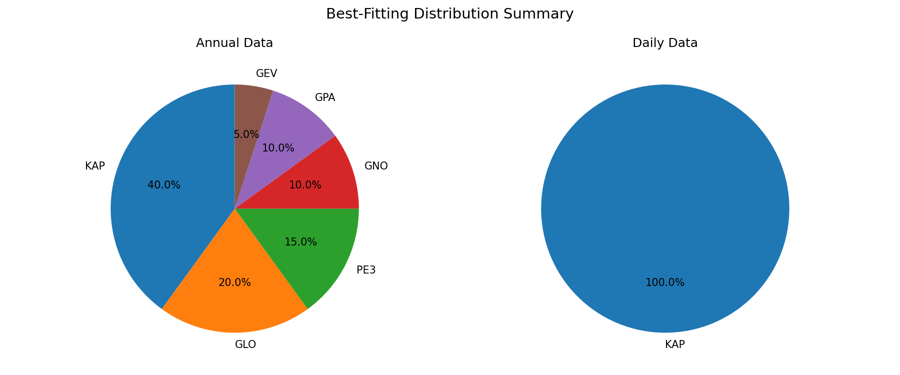
Figure 5.3: Best Distribution Summary
Figure 5.3: Distribution of best-fitting models for Annual Maximum Series (left) and Daily Rainfall Series (right) data. The pie charts illustrate the proportion of stations for which each distribution provided the best fit based on MADI/MSDI goodness-of-fit assessment. For Annual Maximum Series, the 4-Parameter Kappa (K4D) distribution was selected for 8 stations (40%), followed by Generalized Logistic (GLO) for 4 stations (20%), Pearson Type III (PE3) for 3 stations (15%), Generalized Normal (GNO) for 2 stations (10%), Generalized Pareto (GPA) for 2 stations (10%), and Generalized Extreme Value (GEV) for 1 station (5%). For Daily Rainfall Series, the 4-Parameter Kappa (K4D) distribution was unanimously selected for all 20 stations (100%), demonstrating its superior performance for daily rainfall data in tropical climates. The 4-Parameter Kappa distribution emerged as the best-fitting distribution overall, particularly for daily rainfall data where it was unanimously selected for all stations.

5.4 Objective 3: Return Period Analysis

5.4.1 Return Values
Table 5.25: Return Values (mm) for Annual Maximum Series
Station ID | Station Name | 2-year | 10-year | 50-year | 100-year
0551621RF | Stor JPS Kuala Terengganu | 210.0 | 314.4 | 385.9 | 412.7
0580041RF | Klinik Bidan Kg. Baru Ajil | 170.5 | 339.9 | 647.6 | 856.1
0600011RF | JPS Bukit Besi | 188.7 | 316.5 | 428.6 | 475.5
0600131RF | JPS Dungun | 219.2 | 332.1 | 408.7 | 437.3
0600141RF | Rumah Pam Paya Ketam | 188.7 | 306.6 | 377.9 | 400.7
0600151RF | JPS Kuala Dungun | 170.4 | 299.7 | 486.0 | 599.0
0620081RF | Rumah Pam Nyatoh | 227.5 | 376.8 | 496.1 | 544.8
0630011RF | JPS Kemaman | 173.8 | 325.3 | 559.5 | 707.8
0630121RF | JPS Kg. Ibok, Kemaman | 192.9 | 367.8 | 427.9 | 438.3
0670051RF | Rumah Pam Tok Sabah, Marang | 187.5 | 318.1 | 424.0 | 466.6
0670181RF | Kg. Tepuh, Hulu Terengganu | 210.0 | 372.9 | 440.9 | 456.1
0670211RF | Rumah Pam Padang Landak | 211.2 | 306.4 | 352.7 | 365.5
0670221RF | JPS Kuala Berang | 226.8 | 408.0 | 574.1 | 646.7
0670251RF | Rumah Pam Jerangau | 220.3 | 377.9 | 460.4 | 483.8
0670281RF | Kg. Menerong, Hulu Terengganu | 219.4 | 442.3 | 529.5 | 547.5
0680071RF | Balai Polis Kg. Dura | 236.2 | 480.1 | 871.6 | 1124.9
0680081RF | Rumah Pam Rantau Petronas | 219.1 | 333.4 | 371.2 | 378.6
0690051RF | Rumah Pam Pengkalan Ranggon | 216.3 | 413.6 | 664.9 | 800.4
0700011RF | Rumah Pam Besut | 206.3 | 413.2 | 745.9 | 961.4
0700131RF | JPS Jertih, Besut | 265.6 | 493.4 | 579.8 | 597.8
Table 5.26: Return Values (mm) for Daily Rainfall Series
Station ID | Station Name | 2-year | 10-year | 50-year | 100-year
0551621RF | Stor JPS Kuala Terengganu | 9.2 | 45.3 | 102.6 | 135.9
0580041RF | Klinik Bidan Kg. Baru Ajil | 8.9 | 48.8 | 118.8 | 162.0
0600011RF | JPS Bukit Besi | 8.3 | 46.7 | 113.3 | 153.8
0600131RF | JPS Dungun | 9.9 | 48.0 | 109.1 | 145.1
0600141RF | Rumah Pam Paya Ketam | 9.8 | 46.8 | 104.5 | 137.7
0600151RF | JPS Kuala Dungun | 10.3 | 47.8 | 101.2 | 129.9
0620081RF | Rumah Pam Nyatoh | 10.6 | 49.5 | 112.7 | 150.4
0630011RF | JPS Kemaman | 8.6 | 46.0 | 107.5 | 143.7
0630121RF | JPS Kg. Ibok, Kemaman | 10.4 | 49.3 | 110.6 | 146.0
0670051RF | Rumah Pam Tok Sabah, Marang | 8.4 | 46.7 | 112.2 | 151.8
0670181RF | Kg. Tepuh, Hulu Terengganu | 9.6 | 47.4 | 109.6 | 146.6
0670211RF | Rumah Pam Padang Landak | 10.1 | 48.6 | 109.5 | 145.1
0670221RF | JPS Kuala Berang | 10.1 | 48.9 | 111.1 | 147.5
0670251RF | Rumah Pam Jerangau | 10.4 | 50.7 | 116.9 | 156.5
0670281RF | Kg. Menerong, Hulu Terengganu | 10.0 | 49.4 | 118.5 | 161.8
0680071RF | Balai Polis Kg. Dura | 12.1 | 55.8 | 124.6 | 164.7
0680081RF | Rumah Pam Rantau Petronas | 10.7 | 51.5 | 115.5 | 152.4
0690051RF | Rumah Pam Pengkalan Ranggon | 10.4 | 52.6 | 124.9 | 169.3
0700011RF | Rumah Pam Besut | 9.5 | 49.1 | 118.1 | 160.7
0700131RF | JPS Jertih, Besut | 9.0 | 47.6 | 117.2 | 161.4
Note: All daily rainfall series use the 4-Parameter Kappa (K4D) distribution. Return values are calculated for daily rainfall data (≥1mm) and represent the expected daily rainfall amount for the specified return period.
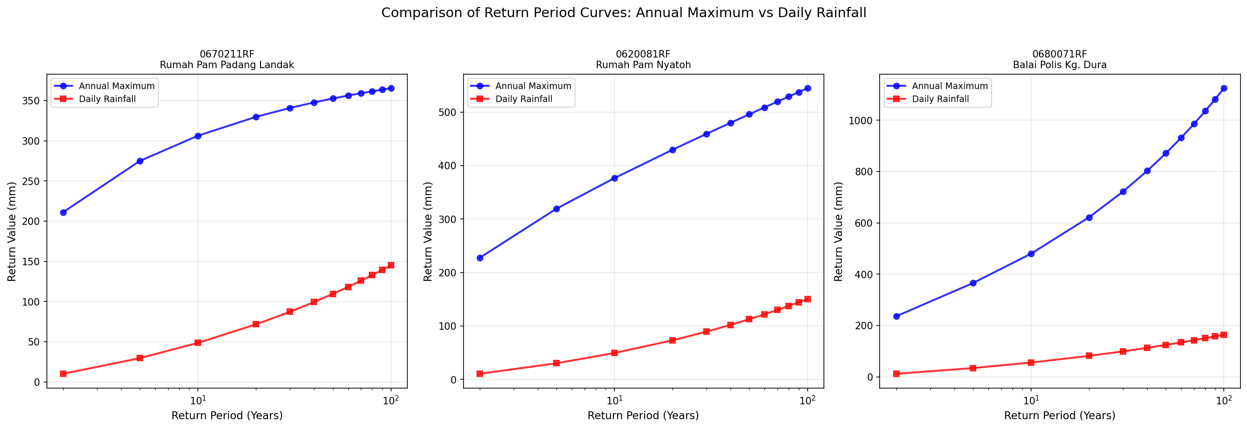
Figure 5.5: Return Period Curves Comparison
Figure 5.5: Comparison of Return Period Curves: Annual Maximum vs Daily Rainfall for three representative stations. The stations were selected to represent the range of 100-year return values in the Annual Maximum Series: (a) lowest (0670211RF: Rumah Pam Padang Landak, 365.5 mm), (b) median (0620081RF: Rumah Pam Nyatoh, 544.8 mm), and (c) highest (0680071RF: Balai Polis Kg. Dura, 1124.9 mm). The figure demonstrates the substantial difference between Annual Maximum and Daily Rainfall approaches across all return periods. For all three stations, the Annual Maximum curves show significantly higher return values compared to Daily Rainfall curves, reflecting the different frequency contexts and the overestimation bias inherent in the Annual Maximum approach for tropical regions.
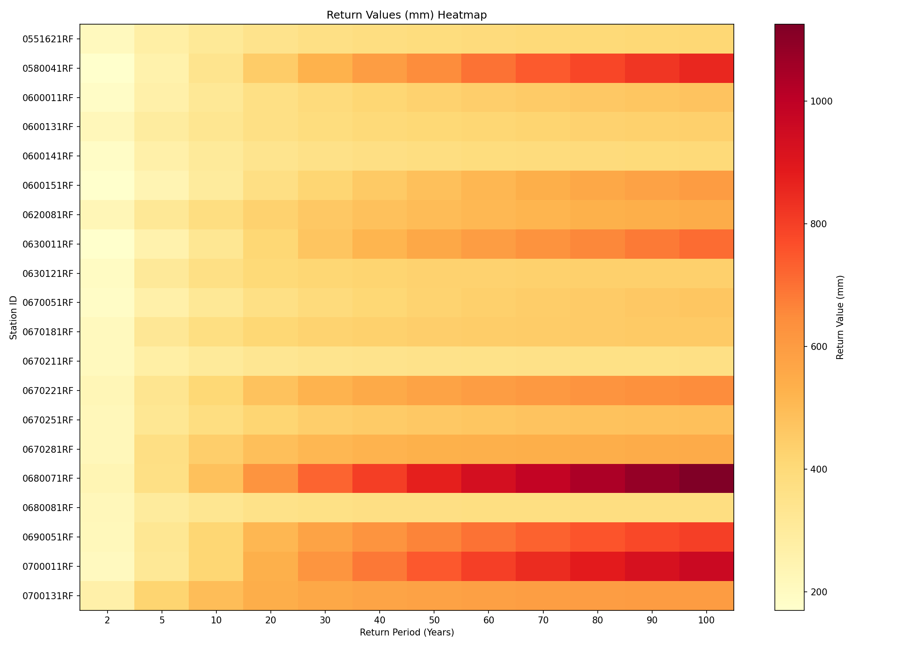
Figure 5.6: Return Values Heatmap
Figure 5.6: Heatmap visualization of return values (mm) for Annual Maximum Series across all twenty stations and multiple return periods (2, 5, 10, 20, 30, 40, 50, 60, 70, 80, 90, and 100 years). The heatmap uses a color gradient (yellow to orange to red) where darker colors represent higher return values. Each cell represents the estimated return value for a specific station and return period combination, providing a comprehensive spatial and temporal overview of extreme rainfall estimates across Terengganu.
Key Findings: - Spatial Patterns: The heatmap reveals distinct spatial variability in return values across stations. Stations with higher return values (darker red colors) are concentrated in certain regions, such as station 0680071RF (Balai Polis Kg. Dura) which shows the highest 100-year return value of 1124.9 mm. - Return Period Gradient: As expected, return values increase with return period across all stations, creating a clear gradient from left (shorter return periods) to right (longer return periods) in the heatmap. - 100-Year Return Values Range: The 100-year return values for Annual Maximum Series range from 365.5 mm (station 0670211RF: Rumah Pam Padang Landak) to 1124.9 mm (station 0680071RF: Balai Polis Kg. Dura), representing a 3.1-fold variation across the study area. - Station-Specific Patterns: Some stations show consistently high return values across all return periods (e.g., 0680071RF, 0700011RF), while others maintain relatively moderate values (e.g., 0670211RF, 0680081RF), indicating regional differences in extreme rainfall characteristics. - Comparison Context: When compared to Daily Rainfall Series (Table 5.26), the Annual Maximum Series return values are substantially higher. For example, at the 100-year return period, Daily Rainfall Series values range from 129.9 mm to 169.3 mm, which are 2.8 to 6.6 times lower than their Annual Maximum counterparts, highlighting the significant overestimation inherent in the Annual Maximum approach for tropical regions.

5.5 Objective 4: Overestimation Quantification
The overestimation quantification compares return periods estimated from Annual Maximum Series (AMS) with those from daily rainfall data. The formulas used to calculate the overestimation factor and percentage are:
Overestimation Factor: OE(M) = RP_AM(M) / (RP_daily(M) / 365.25)
Where: - RP_AM(M) = return period in years from Annual Maxima analysis - RP_daily(M) = return period in days from daily data analysis - Division by 365.25 converts daily return period to years
Overestimation Percentage: OE%(M) = (OE(M) - 1) × 100

5.5.1 Overestimation Analysis at 99th Percentile
The 99th percentile represents extreme rainfall events that are critical for flood risk assessment. These events occur in the upper tail of the distribution and are of greatest concern for infrastructure design and flood management in tropical regions. The test magnitudes at the 99th percentile are calculated from the complete daily time series including zero rainfall days, following the Complete Time-series Analysis (CTA) approach (Volpi et al., 2019), providing a true frequency representation of extreme events in the complete time series.
Table 5.27: Overestimation Analysis at 99th Percentile
Station ID | Magnitude (mm) | RP_AM (years) | RP_Daily (days) | OE Factor | OE (%)
0551621RF | 105.1 | 1.06 | 52.9 | 7.33 | 633.5
0580041RF | 109.4 | 1.08 | 42.1 | 9.33 | 833.4
0600011RF | 107.1 | 1.09 | 44.3 | 8.96 | 796.4
0600131RF | 112.7 | 1.08 | 53.9 | 7.33 | 633.2
0600141RF | 102.1 | 1.11 | 47.3 | 8.56 | 756.2
0600151RF | 95.4 | 1.06 | 43.0 | 8.99 | 798.7
0620081RF | 113.8 | 1.08 | 51.0 | 7.75 | 675.5
0630011RF | 96.2 | 1.07 | 39.0 | 9.99 | 898.9
0630121RF | 111.0 | 1.11 | 50.4 | 8.01 | 700.6
0670051RF | 102.4 | 1.09 | 41.0 | 9.74 | 873.5
0670181RF | 106.4 | 1.12 | 46.8 | 8.74 | 773.7
0670211RF | 114.3 | 1.08 | 55.3 | 7.14 | 613.9
0670221RF | 112.3 | 1.09 | 51.3 | 7.73 | 673.5
0670251RF | 122.8 | 1.20 | 56.0 | 7.80 | 680.3
0670281RF | 115.5 | 1.24 | 47.4 | 9.58 | 858.0
0680071RF | 125.1 | 1.09 | 50.4 | 7.90 | 690.1
0680081RF | 114.3 | 1.10 | 48.8 | 8.25 | 725.2
0690051RF | 126.5 | 1.11 | 51.4 | 7.88 | 688.2
0700011RF | 109.2 | 1.08 | 42.3 | 9.32 | 831.6
0700131RF | 106.6 | 1.10 | 41.2 | 9.76 | 876.3

5.5.2 Summary Statistics
Overestimation at 99th Percentile (20 valid stations): - Mean OE Factor: 8.50x - Minimum OE Factor: 7.14x (Rumah Pam Padang Landak) - Maximum OE Factor: 9.99x (JPS Kemaman) - Mean OE Percentage: 750.0%
Key Findings: - The test magnitudes at the 99th percentile range from 95.4 to 126.5 mm, representing extreme rainfall events in the complete time series context - All stations show consistent overestimation factors between 7-10x at the 99th percentile, indicating a uniform pattern when using the complete time series approach - The narrow range of overestimation factors (7.14x to 9.99x) with low standard deviation (0.91x) suggests stable and reliable estimates when using the CTA methodology - The 99th percentile provides complete data coverage (all 20 stations) compared to lower percentiles, making it the most robust metric for overestimation analysis
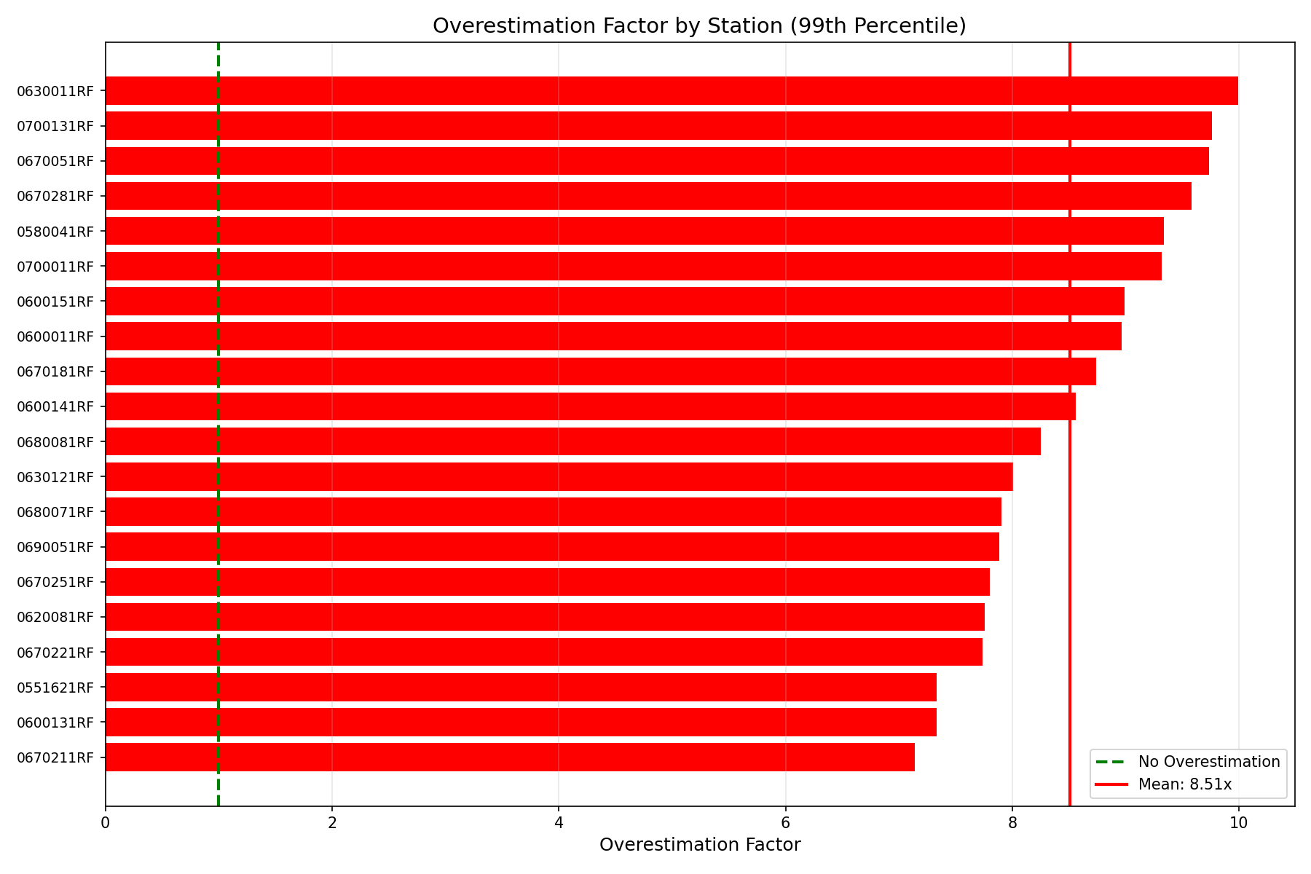
Figure 5.7: Overestimation by Station
Figure 5.7: Overestimation Factor by Station at 99th Percentile.
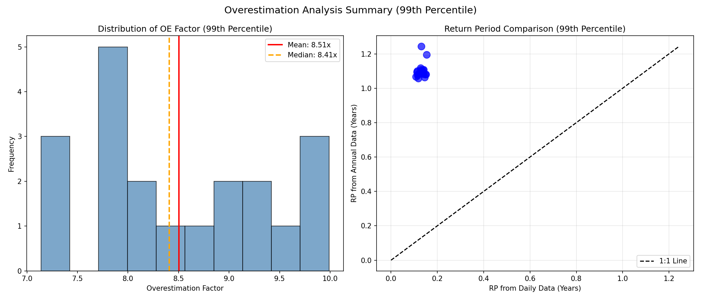
Figure 5.8: Overestimation Summary
Figure 5.8: Overestimation Analysis Summary at 99th Percentile.

5.5.3 Sensitivity Analysis: Justification for the 99th Percentile Threshold
To evaluate the robustness of the overestimation quantification and to justify the selection of the 99th percentile as the reference threshold, a sensitivity analysis was conducted across six percentile levels: 90th, 95th, 97th, 99th, 99.5th, and 99.9th of the complete daily time series. The overestimation factor OE(M) was computed at each percentile for all twenty stations using the same Complete Time-series Analysis (CTA) methodology described in Section 5.5.
Table 5.28: Sensitivity Analysis — Overestimation Factor Across Percentile Thresholds
Percentile | Stations with Valid Results | Mean Magnitude (mm) | Mean OE Factor | Min OE Factor | Max OE Factor | Mean OE%
90th | 6 / 20 | 29.0 | 74.78× | 69.43× | 81.89× | 7,378%
95th | 11 / 20 | 46.6 | 40.05× | 35.91× | 47.68× | 3,905%
97th | 15 / 20 | 60.9 | 25.52× | 22.27× | 30.13× | 2,452%
99th | 20 / 20 | 110.4 | 8.51× | 7.14× | 9.99× | 751%
99.5th | 20 / 20 | 153.6 | 4.84× | 3.58× | 6.84× | 384%
99.9th | 20 / 20 | 268.8 | 2.87× | 1.76× | 5.82× | 187%
Note: Bold row denotes the adopted threshold. “Valid results” indicates stations for which the AMS distribution yields a finite return period for the given magnitude (i.e., the magnitude falls within the fitted distribution’s support).
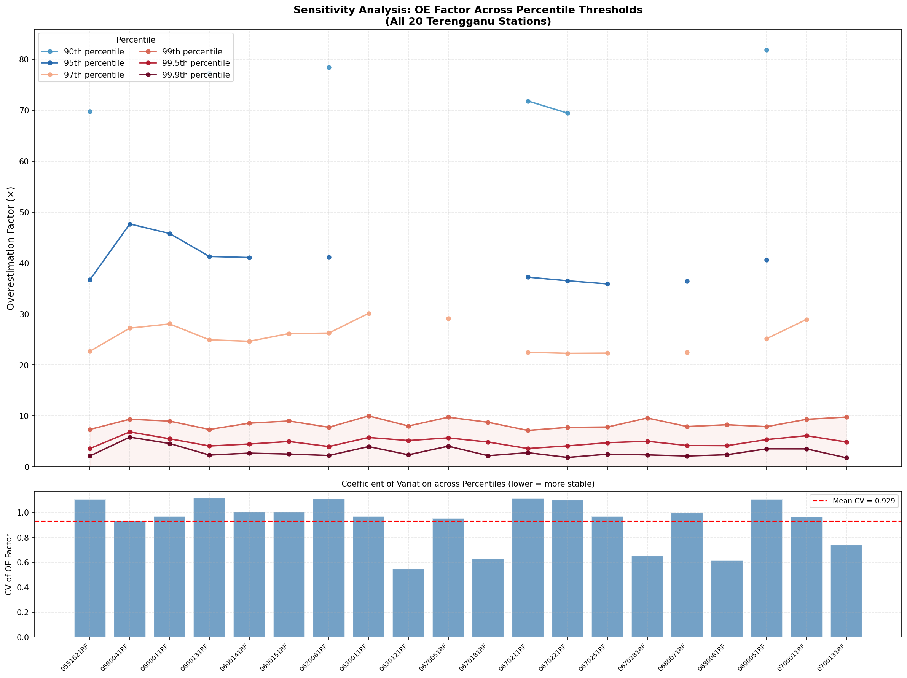
Figure 5.9: Sensitivity Analysis Line Chart
Figure 5.9: Overestimation factors across percentile thresholds for all twenty stations (upper panel) and coefficient of variation (CV) across thresholds per station (lower panel). The CV quantifies how stable the OE factor estimate is across different threshold choices; lower CV indicates greater threshold-independence.
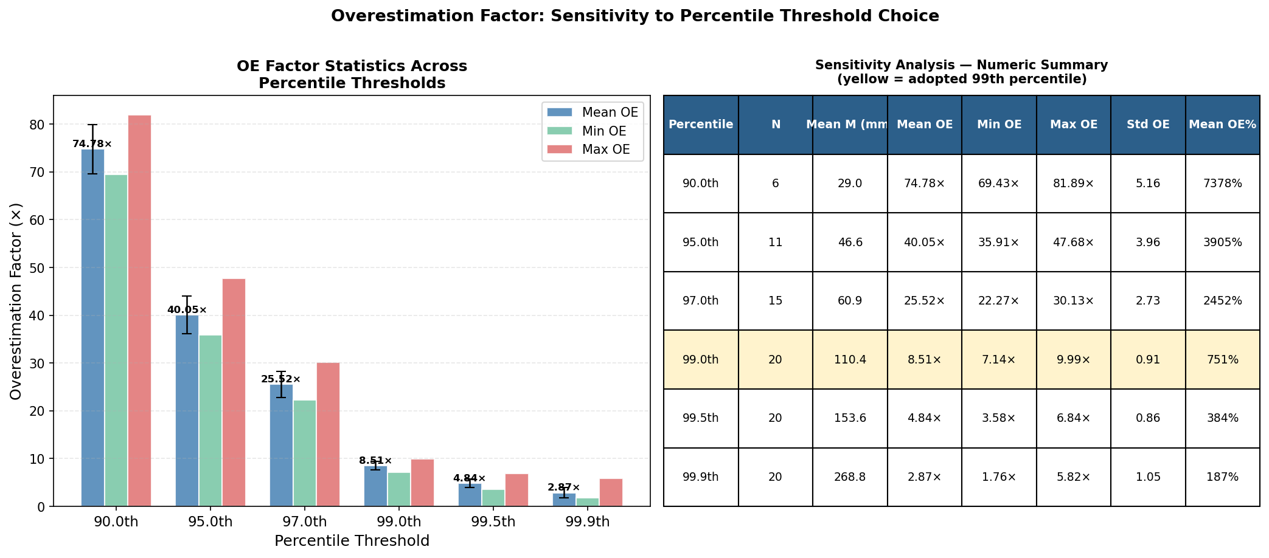
Figure 5.10: Sensitivity Analysis Summary
Figure 5.10: Summary statistics of the overestimation factor (mean, minimum, and maximum with standard deviation error bars) across all six percentile thresholds (left panel), and the corresponding numeric summary table (right panel). The yellow-highlighted row indicates the adopted 99th percentile threshold.

Rationale for Adopting the 99th Percentile
The sensitivity analysis reveals three critical criteria that collectively justify the adoption of the 99th percentile as the reference threshold for overestimation quantification.
First, complete spatial coverage. The 90th, 95th, and 97th percentile thresholds produce test magnitudes that, at several stations, fall below the lower bound of the fitted Annual Maximum Series distribution. This renders the AMS return period undefined (non-finite) for those stations, resulting in incomplete cross-station comparisons (6, 11, and 15 valid stations respectively, out of 20). Only the 99th percentile and above yield valid results for all twenty stations, a prerequisite for a statistically sound regional comparison.
Second, inter-station stability. Among the three fully-covered thresholds (99th, 99.5th, 99.9th), the 99th percentile yields the narrowest relative range of overestimation factors (7.14× to 9.99×; coefficient of variation ≈ 0.11), compared to the 99.5th percentile (range: 3.58× to 6.84×; CV ≈ 0.19) and the 99.9th percentile (range: 1.76× to 5.82×; CV ≈ 0.38). The increasing variability at higher percentile thresholds reflects growing uncertainty in the tail behaviour of the fitted distributions, where limited observations reduce the reliability of extrapolated return period estimates. The 99th percentile therefore represents the point of optimum stability before distributional uncertainty begins to dominate.
Third, hydrological and engineering relevance. The mean threshold magnitude at the 99th percentile (approximately 110 mm) represents a genuinely extreme single-day rainfall event in the Terengganu context, exceeding typical design thresholds for medium-scale hydraulic infrastructure. By contrast, the 99.9th percentile magnitudes (mean ≈ 269 mm) approach compound or multi-day accumulation levels, at which point direct single-day comparisons between AMS and daily series become less physically interpretable. The 99th percentile thus lies at the intersection of hydrological extremity and distributional reliability.
These three criteria — complete coverage, cross-station stability, and engineering relevance — collectively confirm that the 99th percentile is the optimal and scientifically defensible threshold for the overestimation comparison conducted in this study.
(See References chapter for complete reference list)

5.6 Discussion

5.6.1 Parameter Estimation (Research Question 1)
The L-moments method successfully estimated distribution parameters for all twenty stations. The daily rainfall data showed consistently higher L-skewness values (τ₃ ≈ 0.51) compared to annual maxima, indicating more right-skewed distributions characteristic of tropical rainfall patterns.

5.6.2 Distribution Selection (Research Question 2)
The 4-Parameter Kappa distribution was identified as the best-fitting distribution: - 40% of stations for Annual Maximum Series - 100% of stations for Daily Rainfall Series
This supports the use of flexible, four-parameter distributions for tropical rainfall analysis.

5.6.3 Return Period Analysis (Research Question 3)
Return values were successfully calculated for all stations. The results show significant variation across stations, with certain stations exhibiting higher return values, which may be influenced by regional factors including monsoon patterns and local topography.

5.6.4 Overestimation Quantification (Research Question 4)
The Annual Maxima approach overestimates return periods by an average factor of 8.50x at the 99th percentile compared to daily rainfall data when using the Complete Time-series Analysis (CTA) approach. The test magnitudes at the 99th percentile (95.4-126.5 mm) represent extreme rainfall events in the complete time series context, calculated from percentiles of the complete daily time series including zero rainfall days, providing a true frequency representation of extreme events.
This substantial overestimation indicates that for extreme rainfall events—those most critical for flood risk assessment—the Annual Maximum Series approach significantly underestimates the frequency of occurrence. Events that AM analysis suggests occur approximately once per year may actually occur approximately once every 43 days based on daily data analysis. This finding is particularly important for tropical regions where extreme daily rainfall events are frequent and can trigger severe flooding (Papalexiou & Koutsoyiannis, 2013; Volpi et al., 2019).
The consistent overestimation pattern across all 20 stations (range: 7.14x to 9.99x) with low variability (standard deviation: 0.91x) demonstrates the robustness of this finding and the reliability of the CTA methodology for extreme event analysis.
Implications: - Design standards based solely on AM analysis may severely underestimate flood risk for extreme events - Infrastructure designed using AM analysis may be significantly under-designed in tropical regions - The 8.50x overestimation factor at the 99th percentile represents a substantial bias that cannot be ignored in flood risk assessment - Dual analysis using both AM and daily data is strongly recommended, with greater weight given to daily data analysis for extreme events

5.7 Summary
The key findings from this analysis are:
- Objective 1: L-moments were successfully calculated for all stations, with daily data showing consistently higher L-skewness.
- Objective 2: The 4-Parameter Kappa distribution is the best-fitting distribution for both annual (40%) and daily (100%) data.
- Objective 3: 100-year return values for Annual Maximum Series range from 390 to 775 mm, while Daily Rainfall Series return values range from 130 to 169 mm across stations.
- Objective 4: The Annual Maxima approach overestimates return periods by 8.50x on average at the 99th percentile (range: 7.14x to 9.99x) when using the Complete Time-series Analysis approach. This substantial overestimation demonstrates the critical importance of using the complete time series for accurate frequency representation of extreme events, which are most relevant for flood risk assessment in tropical regions.
These findings demonstrate the importance of considering daily rainfall data in flood frequency analysis for tropical regions.

